**Tutorial 19: Using Teleport**

Teleport component is a new feature Vue 3. Teleports lets us move content that we create inside our Vue app to a different place in the DOM entirely. It can be outside the scope of the Vue app itself.

Make sure **Tutorial 18** is complete to be able to move on to this tutorial or clone the [vue3-firebase-course](https://github.com/younggrasshopperza/vue3-firebase-course) repository and go to branch called **Tutorial-18**.

**Step 1:** In the **index.html** file, create a div tag with a class called modals under the div tag with the id app.

Look at the example below (**Line 16**):

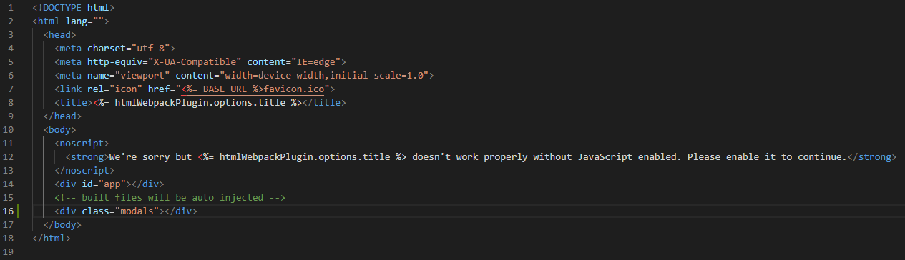

In the **App.vue** file, replace the div tag with the condition **showModal** to a teleport tag. Include a to attribute with a class called modals.

Look at the example below (**between line 4 to 13**):

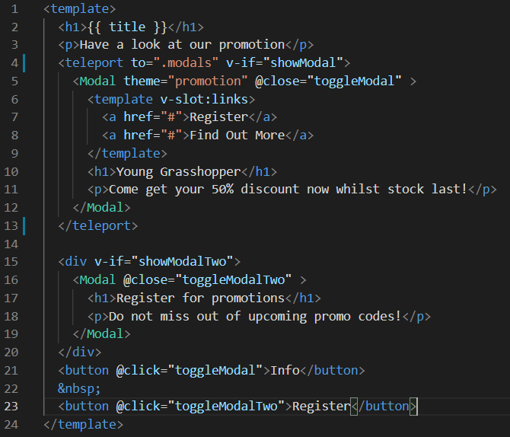

The output will look exactly the same but when you inspect the code you will see that the code has teleported to the div tag with the class modals.

**Output:**

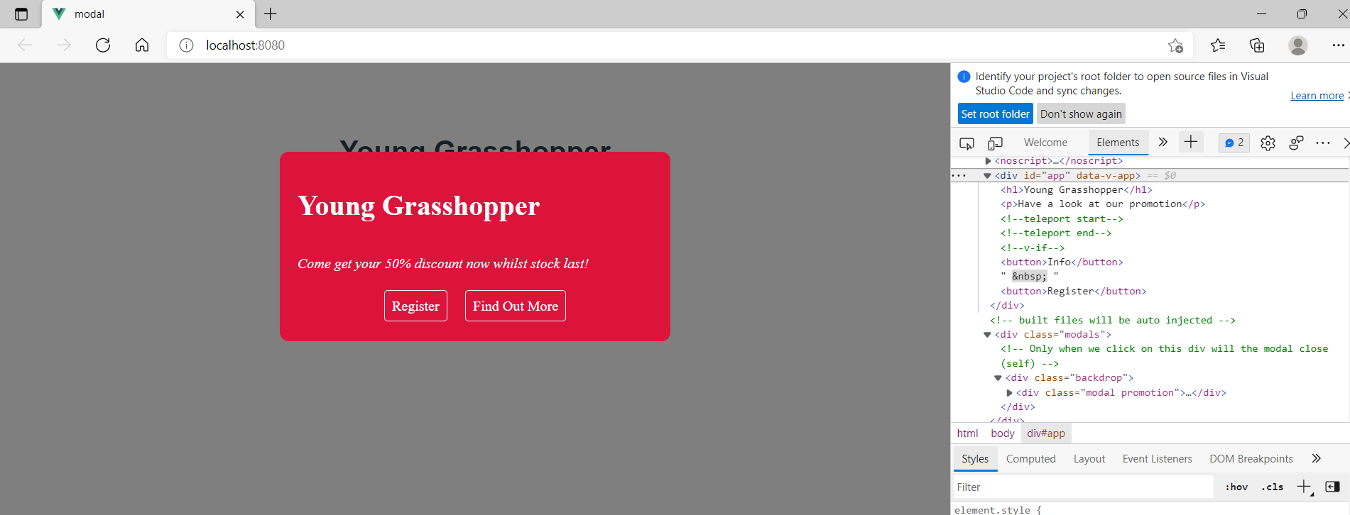

**Step 2:** In the **App.vue** file, replace the div tag with the condition **showModalTwo** to a teleport tag. Include a to attribute with a class called modals.

Look at the example below (**between line 15 to 20**):

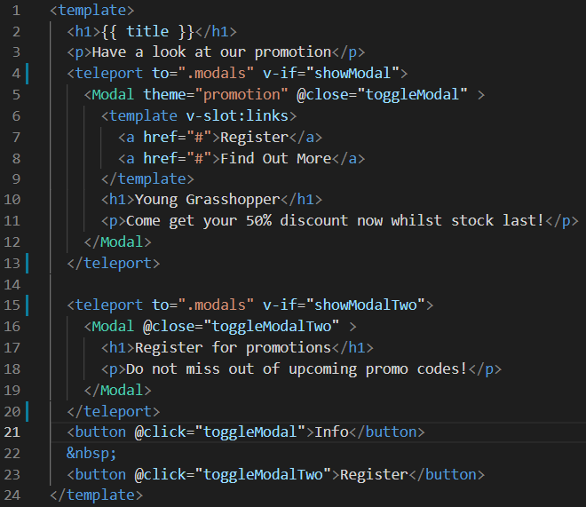

**You can view the code snippets from the** [**vue3-firebase-course**](https://github.com/younggrasshopperza/vue3-firebase-course) **repository under the Tutorial-19 branch**.